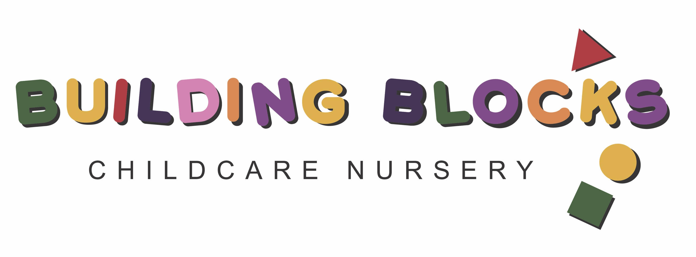

Fife Council Early Learning and Childcare

Partner Provider Application Form

2022-23

- HILD’S DETAILS
Forename(s) : |  | Known As :
Surname :
Date of Birth : |  | Sex (please tick): Male Female
Please enter birth certificate OR passport details – this is used to create a unique record for your child
Birth Certificate Country of Issue: ………………………………  Birth Certificate Number: ……………...………………………… |  | Passport Country of Issue: ……………………….  Passport Number: …………………………………
For UK birth certificates the number is in 3 parts: District/Year of Birth/Entry No. e.g. 763/2013/123 (Scottish) or LON/2013/123

Address :

Postcode:
Telephone No:

- FAMILY DETAILS
Main Contact (Applicant)
Title : | Forename : |  | Surname :
Sex (please tick): Male Female |  | Can Collect Child (please tick): Yes No
Email Address :
Address (if different from child’s address) :

Postcode:
Daytime Phone No :
Home Phone No :
Mobile Phone No :
Contact in emergency (please tick) : Yes No |  | Relationship to child: …………………………………….
Additional Contact(s) - please list all individuals with parental responsibility for the child
Title : | Forename : |  | Surname :
Sex (please tick): Male Female |  | Can Collect Child (please tick): Yes No
Email Address :
Address (if different from child’s address) :

Postcode:
Daytime Phone No :
Home Phone No :
Mobile Phone No :
Contact in emergency (please tick) : Yes No |  | Relationship to child: …………………………………….

- PLACES REQUESTED
Nursery and Session Length
Partner Provider
 | Mon | Tues | Wed | Thur | Fri
Start Time
Finish Time
No of hours attending per day
No of hours of funded ELCC Claimed per week (max 30hr IF Term Time – less if full year please ask Setting)

Does your child currently attend another nursery? | Yes No

SHARED CARE – Local Authority or other Partner Establishment where funded ELCC claimed
Name of Nursery
 | Mon | Tues | Wed | Thur | Fri
Start Time
Finish Time
No of hours per day

- INTENDED PRIMARY SCHOOL (please list school if known – this information is not used in the allocation of any place awarded for nursery)
Name of School |  | Local Authority Primary | Non Local Authority Primary | Unknown

CHILD HEALTH INFORMATION
Health Conditions
Does your child have an additional support need?  (e.g. developmental delay, learning difficulty, long term illness) |  |  |  |  |  |  |  | Yes No Not Disclosed
If yes, please give details
Has there been a professional assessment? |  |  |  |  |  |  | Yes No
If yes, can you provide a copy of this assessment? |  |  |  |  |  |  | Yes No
Doctors Details
Health Board |  | Fife |  |  | Other (please list): ………………………………………………………………….
Practice | ………………………………………………………………………………………………………………….…….
Medical Conditions
Does your child have any medical conditions (including any allergies) |  |  |  |  |  | Yes No Not Disclosed
If yes, please give details
Concerns - Please give details below of any concerns you have about your child
Sight |  |  |  | Yes No |  | Please give additional information if you have ticked ’Yes’ to any question(s):
Hearing |  |  |  | Yes No
Speech/Language |  |  |  | Yes No
Coordination and movement |  |  |  | Yes No
Behaviour |  |  |  | Yes No
Toileting |  |  |  | Yes No
Other |  |  |  | Yes No

Dietary Requirements
Does your child have any dietary requirements? |  | Yes No Not Disclosed
If yes, please give further details

- CHILD’S NON EDUCATION CONTACT (usually your Health Visitor)
Name
Address
Postcode |  | Telephone No.
Email
Designation

- Looked After STATUS (Please only complete if applicable)
Local authority responsibility for Child’s Plan
Date
Looked After Status
Legislation

EQUAL OPPORTUNITIES MONITORING (this information is not used when allocating places)

ETHNIC ORIGIN (Please tick one category)
African – African/British/Scottish | Caribbean or Black - Caribbean/British/Scottish | White - Gypsy Traveller
African – Other | Caribbean or Black - Other | White – Irish
Asian - Bangladeshi/British/Scottish | Mixed or multiple ethnic groups | White – Other
Asian - Chinese/British/Scottish | Not Disclosed | White - Other British
Asian - Indian/British/Scottish | Not Known or divulged | White - Polish
Asian – Other | Other Arab | White - Scottish
Asian - Pakistani/British/Scottish | Other (please specify): …………………………………………………………………….

CHILD’S RELIGION (Please tick one category)
Buddhist | Muslim | Sikh
Christian | None | Not Known or not divulged  ………………………………………………..
Hindu | No religion
Jewish | Other (please specify): ……………………………………………………………………..

NATIONAL IDENTITY (Please tick one category)
British | Not Disclosed | Scottish
English | Not Known or divulged | Welsh
Northern Irish | Other (please specify): …………………………………………………………………….

ASYLUM STATUS (Please tick one category if applicable)
Asylum Seeker | Refugee

- MAIN HOME LANGUAGE
Main Language spoken | ……………………………………………………………………………………………….
Additional Language(s) spoken | ……………………………………………………………………………………………….
Level of English (Please tick one category for level of English) :
New to English |  | Competent | Limited communication
Early Acquisition |  | Fluent | Not assessed
Developing competence |  | English as ‘a first language’

DECLARATION

I declare the information on this form to be correct to the best of my knowledge.
Signature | ………………………………………………………….
Print Name | …………………………………………………………. | Date | …………………….……
Fife Council uses the information provided by you to support your child during the course of his/her nursery and school career. Further information on how you and your child’s information is used by Fife Council can be found here www.fife.gov.uk/privacy/education

OFFICE USE ONLY
Date Application Received
Proof of Birth Date seen | Yes No
Proof of Address seen | Yes No
Type of Proof of Address seen

Guidance on Completing Application Form

2022-23

General Information
Please fully complete all sections of the application form if applicable to you. If you need any help in doing this please contact your partner provider early learning and childcare establishment.

Evidence Requested for ALL APPLICATIONS
For any application, you must provide evidence of your child’s date of birth (either birth certificate or passport) along with proof of your address (council tax bill, utility bill, bank statement, driving licence, child benefit award letter or NHS registration card) and any other eligibility criteria required (such as proof of benefits if applying for a 2 year old placement). Please note we will be unable to accept your application unless this information is provided. “ year old applications must be handed in to a Local Authority Nursery that offers 2 year old place for processing.

Section 2: FAMILY DETAILS
Please list all individuals with parental responsibility for the child along with any additional emergency contacts. A continuation sheet is available for additional contacts either online at www.fifedirect.org.uk/earlyyears or by contacting any Fife Council nursery.

Section 7: LOOKED AFTER STATUS
Please complete this section only if it applies to your child.
The looked after status would be either, looked after at home, looked after away from home or previously looked after. If you are unsure which legislation is relevant to your personal circumstances, please speak to your social worker for advice.

