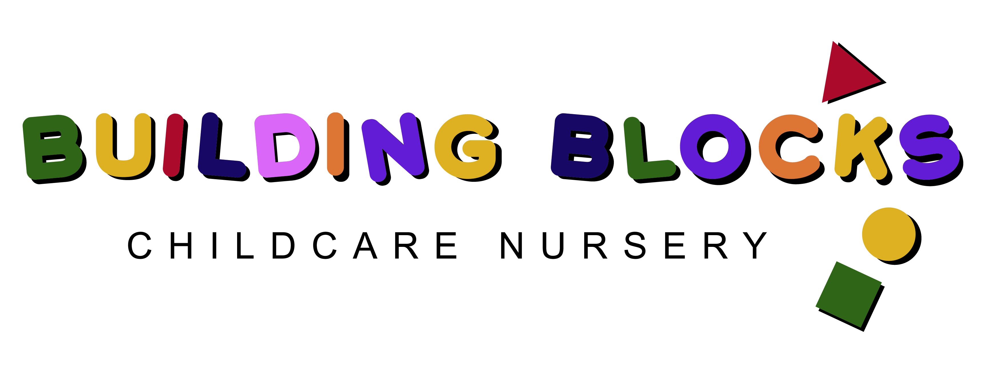

GENERAL PERMISSION FORM & EMERGENCY CONTACT FORM

CHILD’S NAME:………………………………………….

DATE OF BIRTH:…………………………………………

Building Blocks Nursery uses the information provided by you to support your child during the course of their time at the nursery. If at any point there is a change to the permission provided below, please contact the nursery.

PHOTOGRAPHS/VIDEOS

Photographs of children are often taken to support learning. These photos may be displayed within the nursery including the front entrance, or in external communications

Parents should note that, to ensure the safety and privacy of all children, performances and activities should not be photographed or recorded without the permission of the nursery – this extends to other family members or friends attending events.

- Are you happy to give your permission for your child to be photographed and for these photographs to be displayed in the nursery including the newsletter which is distributed to parents? Please circle

YES NO

- Are you happy to give your permission for your child to be included in photographs for the local press or for use in promotional materials? Please circle

YES NO

- Are you happy for your child to be included in photographs, which may be used on our nursery Facebook page? Please circle

YES NO

- Are you happy for your child to be included in photographs, which may be used on our nursery website? Please circle

YES NO

- I understand and accept the terms and conditions stated on social media sites and that photographs should not be taken from the nursery media pages and redistributed e.g. on Instagram etc

YES NO

GENERAL CORRESPONDENCE AND NEWSLETTERS

General correspondence and newsletters are mainly circulated electronically which require you to share your email address and mobile telephone number with the nursery.

Are you happy for the nursery to contact you in this way? Please circle

YES NO

Email address:…………………………………………………………………………..

Mobile Telephone Number: ………………………………………………………

OUTINGS

The children are sometimes taken out on walks e.g. local forest or to visit places of interest. Risk assessments are completed prior to any outing. Usually these are planned in advance and parents are notified a few days before the outing, however, sometimes it can be part of the children’s on the spot learning e.g. a walk to the local post office.

Are you happy for your child to take part in outings with the nursery? Please circle

YES NO

MEDICAL RESPONSE

I give permission for my child to be attended to by a doctor or taken to hospital, in an emergency situation if emergency contacts cannot be reached. Please circle

YES NO

I consent to nursery staff administering first aid treatment considered necessary during the time my child is attending the nursery. Please circle

YES NO

If you circle ‘NO’ to either statements above, please explain:

………………………………………………………………………………………………………………

………………………………………………………………………………………………………………

RELIGION/BELIEFS

Is there any specific information you wish to make us aware of regarding your religion or beliefs?

………………………………………………………………………………………………………………

………………………………………………………………………………………………………………

ANY NOTES/COMMENTS

………………………………………………………………………………………………………………

………………………………………………………………………………………………………………

………………………………………………………………………………………………………………

………………………………………………………………………………………………………………

Emergency Contact form

Child’s Details
Child’s Name
D.O.B.
Address

Doctor’s Name
Doctor’s Tel. No.
Allergies
Foods to avoid
Medication

Emergency Contact 1
Name
Relationship to Child
Address (if different from Child’s address)
Home Tel. No.
Work Tel. No.
Mobile Tel. No.

Emergency Contact 2
Name
Relationship to Child
Address (if different from Child’s address)
Home Tel. No.
Work Tel. No.
Mobile Tel. No.

Parent/Guardian Signature: ______________________________

Date: ___________________________

